**How to set-up a new database using mySQL and phpMyAdmin?**

In this guide, we will learn how to set up a new database called **GuideDatabase** with a table called **GuideTable.**

**Step 1:**

* On the raspberry pi, access phpMyAdmin using localhost/phpMyAdmin/index.php
* Username: root
* Password: dewa123

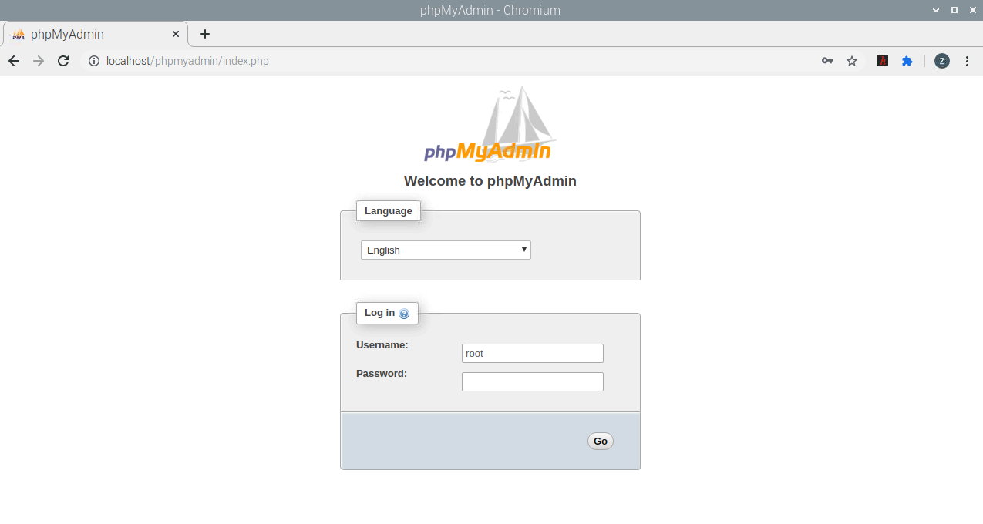

**Step 2:**

* Click on “New” button on the leftmost side of the screen
* You will be directed to this page with the current databases
* Enter a new database name and click on “Create” to build a new database

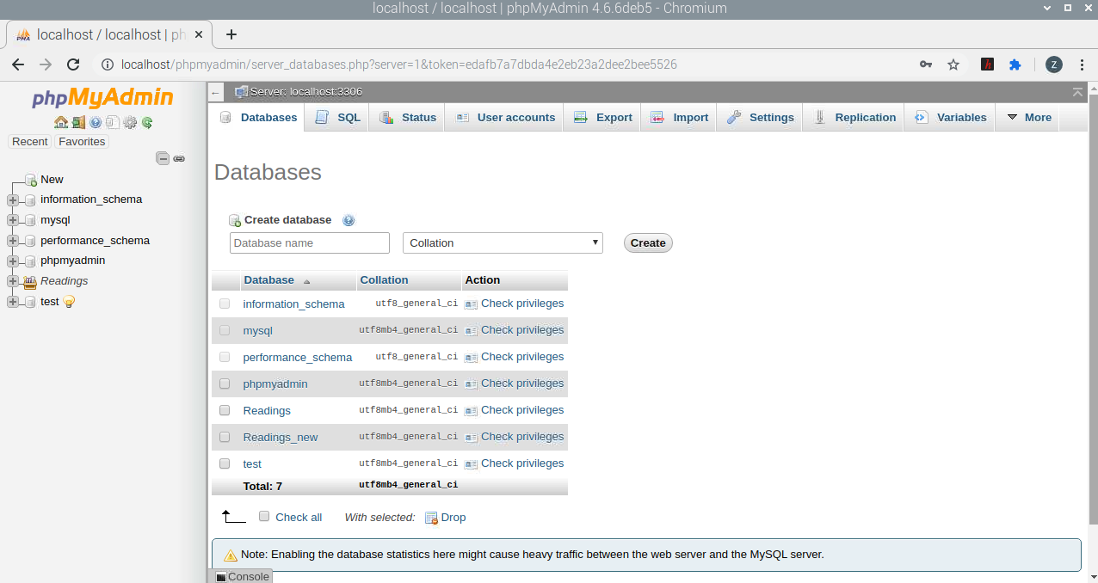

**Step 3:**

* After the new database is created, you will be directed to this page which will allow you to create and add tables to your database.
* Enter the name of your table and specify the number of columns that the table is supposed to have and click on “Go”.
* I chose the table to be called: GuideTable with columns = 4

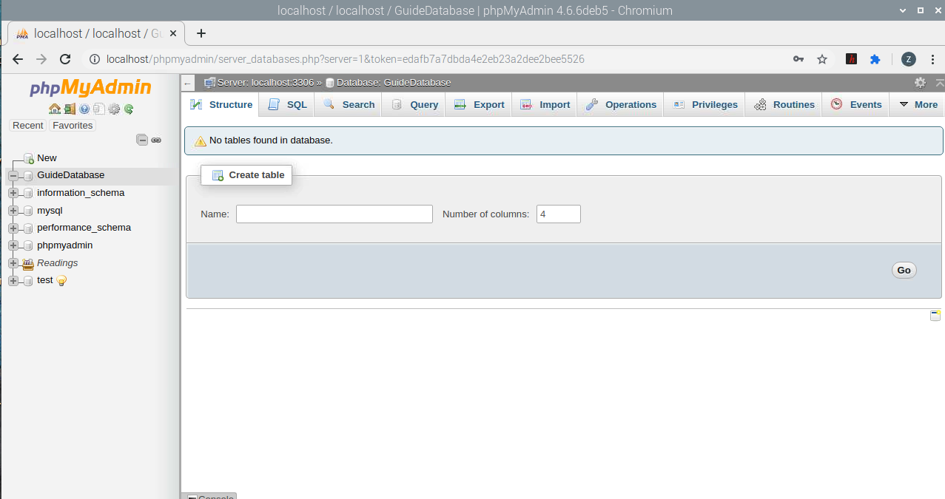

**Step 4:**

* After pressing “Go” in the previous step, you will be directed to this page, where you must specify the column criteria and then press “Save” at the bottom of the page.
* Pay attention to the vertical and horizontal scrollbars on this page to get all the options
* Here, I am taking ID to be the primary key which is auto incremented. The primary key can be chosen based on preference.

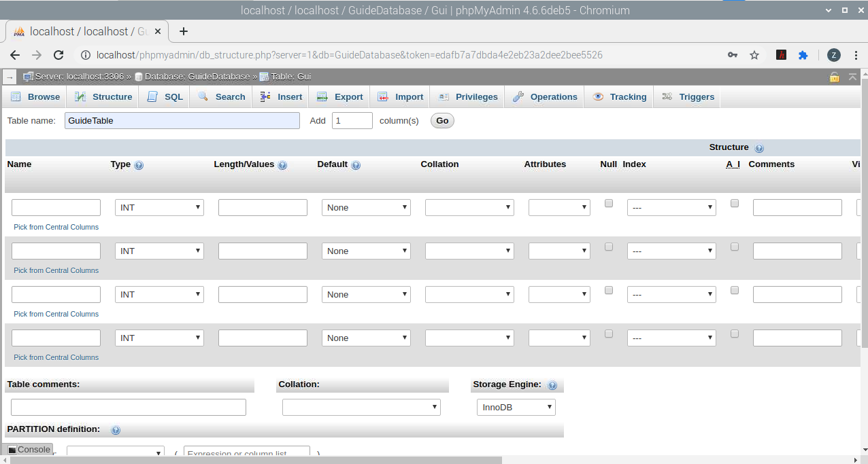

Enter the column names

Select this checkbox to enable auto increment. This is done usually for the ID (primary key in this case).

Specify the length of the column

Specify the data type of the column

ID (the usual primary key) and Date are two columns which are not Null. For all other columns, select the checkbox so they can be set to “Null” value.

Set the “Default” value for ID column as None and CURRENT_TIMESTAMP for the Date column. All other columns can be set as Null.

After the necessary fields have been added for the columns:

Add multiple new columns when building your table and press “Go”.

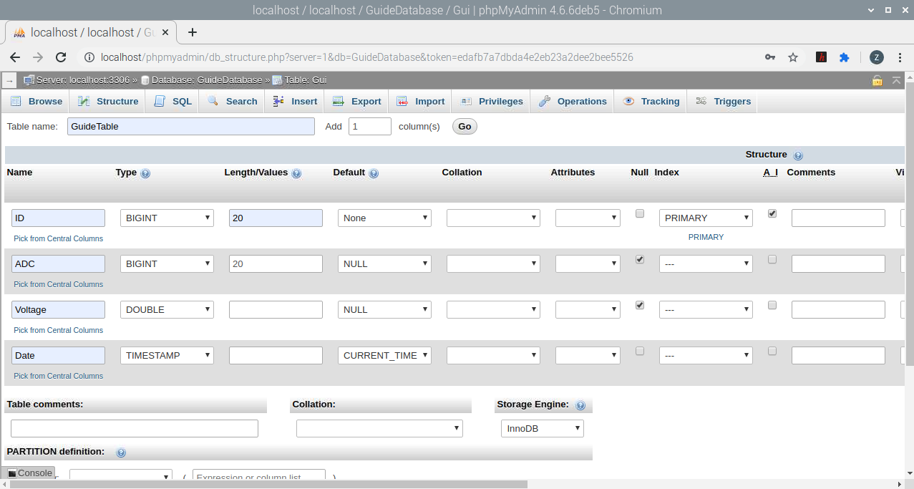

After the table is created:

* This is the page where you will view your entries into your table in your database.

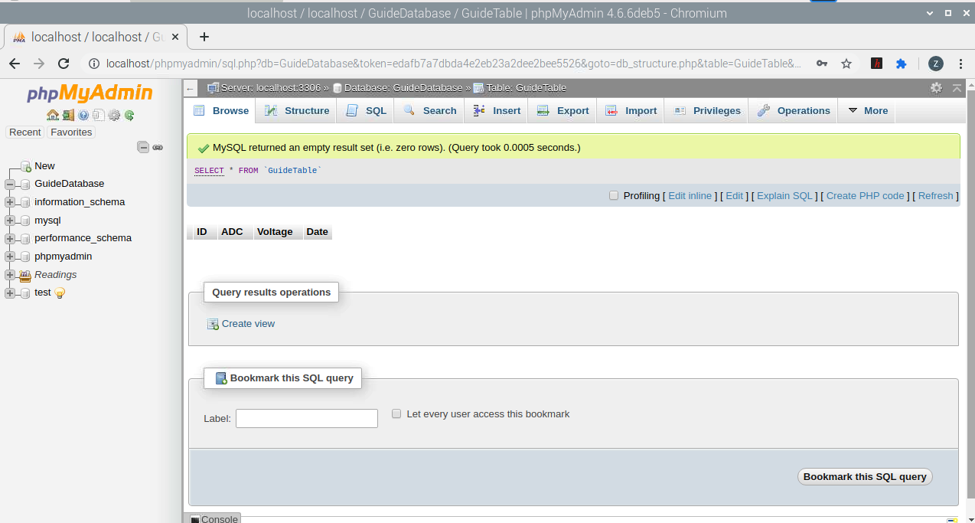

**Step 5:**

* While in your table, select the “Structure” tab where you can modify your existing table. You can change existing columns and add new columns too.

Structure tab

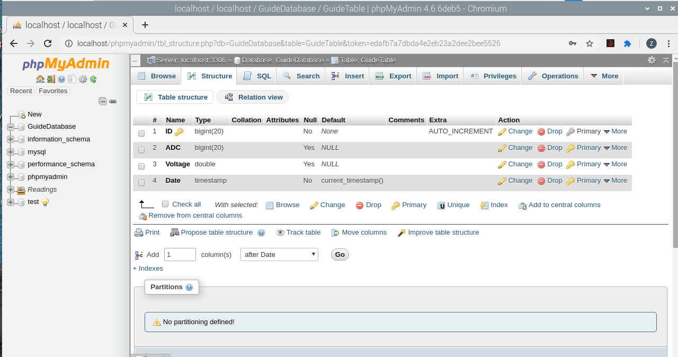

**Step 6:**

* Selecting the database name “GuideDatabase” on the leftmost list will give this screen which displays the tables present within the database. There is only one table present currently within the database called “GuideTable”.
* Selecting the table “GuideTable” will allow us to view the contents of the table and modify the table too.

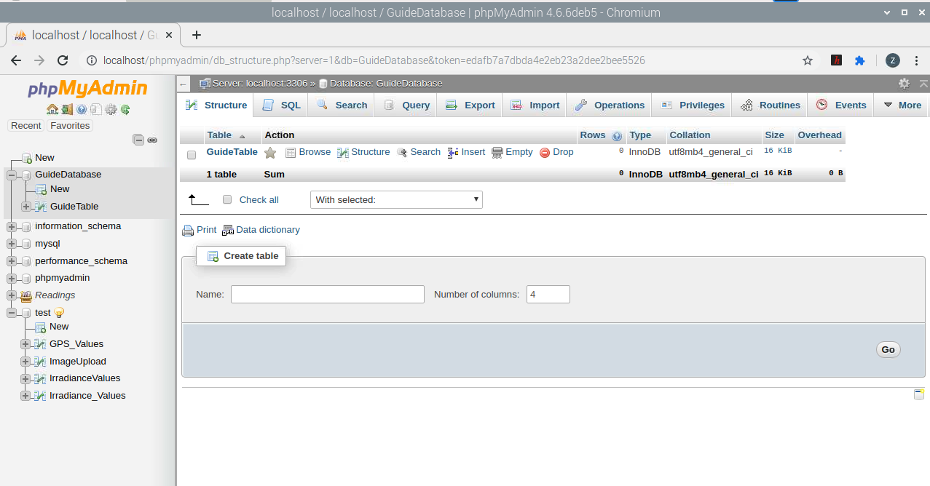

**Step 7:**

* Once the table name is selected as shown in the previous step, you will be directed to this page.
* Under the “Browse” tab, you will be able to view the contents of the table.
* Click on “Refresh” button to keep updating the table within the database.

